### Title

The Australian neighbourhood land-use profile dataset

### Authors

Ali Lakhani 1,2, Dennis Wollersheim1

**Affiliations**

1 School of Psychology and Public Health, La Trobe University, Melbourne, Victoria, Australia, 3008

2 The Hopkins Centre, Menzies Health Institute Queensland, Griffith University, Meadowbrook, Queensland, Australia, 4131

Corresponding author: Ali Lakhani (a.lakhani@latrobe.edu.au)

### Abstract

The land-use profile surrounding a neighbourhood is a determinant of health and associated with socioeconomic outcomes. In Australia, there is no national publicly available dataset detailing the land-use profile surrounding residential neighbourhoods. Using PostGIS a centroid was placed in every Australian Bureau of Statistics (ABS) defined Mesh Block (MB) – the smallest geographical structure in Australian geography which details the category of land-use (i.e. residential, parkland, commercial, industrial etc.) and population. The remoteness classification and socioeconomic status – as defined by the ABS – was joined to each MB. After a buffer based on a radius of 400 metres, 1-kilometre, 2-kilometres, and 5-kilometres was calculated around each centroid, the square metre of, and the percentage of the buffer covered by, each land-use category was calculated. This dataset will support the decisions of urban planners, diverse government departments, researchers and those involved in public and environmental health.

### Background & Summary

The purpose of land surrounding a residential area is associated with diverse health, wellbeing and socioeconomic outcomes. For example, proximity to public transportation is associated with increased residential house prices 1. Areas nearer to tertiary education institutions are likely candidates for knowledge-based industries 2. Living near natural environments, contribute to improved social relationships for people with disability 3.

Consequently, it is unsurprising that measuring the purpose of land surrounding a residence is essential towards the development of indices and measures which are also associated with health and wellbeing outcomes. Examples of such indices include land-use mix measures 4 and resulting measures of walkability 5. Land-use mix is associated with mortality in ageing adults 6, and while also with active commuting for people in urban centres 7. While increased walkability is associated with improved quality of life for ageing adults 8 and a lower risk of cardiovascular disease 9.

Mesh blocks (MBs) are the smallest geographical area in Australia and are defined by the Australian Bureau of Statistics (ABS) 10. Australia has 358,122 MBs and they are designated as one of ten categories: residential, commercial, industrial, parkland, education, hospital/medical, transport, primary production, water, and other. Most populated MBs include between 30 to 60 dwellings.

In Australia, a publicly available national dataset clarifying the purpose of MBs neighbouring a residential MB is non-existent. Such information can inform the decisions of policy makers, urban and health service planners, researchers and the general public. In particular, such information could also inform those interested in the development of measures and indices which are used to predict or explain health and wellbeing outcomes. Consequently, this project involved developing a dataset which clarified the percentage of land-use surrounding a 400 metre, 1-kilometre, 2-kilometre and 5-kilometre radii of all MBs in Australia. These areas were used as 400 meters 11, and between 1 and 2 kilometres 12 are standard distances used for measures of walkability. Five kilometres was considered as recent social distancing policy in the state of Victoria under the context of COVID-19 has required people located within metropolitan Melbourne to remain within a 5-kilometre distance of their home 13. In the instance where a similar measure is used by other states or councils, it was expected that this data would be useful.

As a part of this project the population and number of dwellings covered across each relevant radius for each residential MB was calculated. Additionally, for each residential MB, the geographic location was linked to the remoteness classification 14, and socioeconomic status 15. This was done so end users could conduct analysis to investigate the impact of remoteness and socioeconomic status on access to specific amenities (for example, hospital/medical, education and/or parklands). The land-use, population and number of dwellings around all non-residential MBs were also calculated. It is expected that this information could also be useful for developers, and health and social service planners. Table 1 below clarifies the data that was used to create the dataset while Figure 1 is the schematic overview which details the process undertaken to generate the dataset.

**Table 1: Data used to develop the dataset**

|  |  |  |
| --- | --- | --- |
| **Data with relevant description** | **Format** | **Source** |
| Australian Mesh Block (MB) structure which includes the land-use category | .csv | ABS 10 |
| Census of Population and Housing: Mesh Block Counts, which includes the number of people and dwellings per MB | .csv | ABS 16 |
| Socioeconomic Status (Index of Relative Socioeconomic Disadvantage) at the Statistical Area 1 (SA1) level | .xls | ABS 15 |
| Australian Statistical Geography Standard Remoteness Structure | .csv | ABS 14 |

**Fig.1**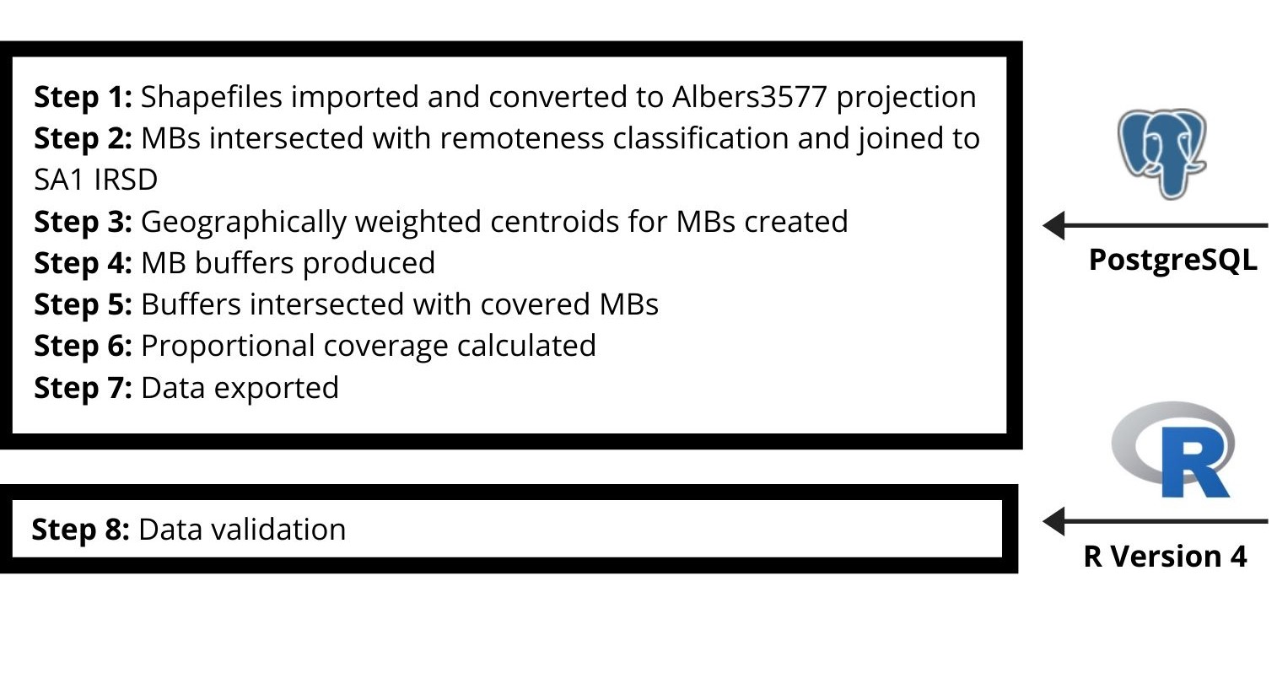

Schematic overview of the dataset creation process.

### Methods

**Data Sources**

Details surrounding the ABS data used – for example, MBs, remoteness classification, and the Index of Relative Socioeconomic Disadvantage (IRSD) - are available via the ABS 10,14-16.

**Spatial Computations**

All data was stored in a PostgreSQL V 12 database 17 and all spatial analysis was conducted via PostGIS using a combination of PostGIS functions and sql commands. The shapefiles were imported using the ‘shp2pgsql’ utility tool and the data was converted to ALBERS 3577 equidistant projection to facilitate distance measurement calculations. Each MB was intersected against the relevant remoteness classification via the function ‘st_intersection’ and MBs were joined to the IRSD score based on their overarching SA1 via sql ‘INNER JOIN’ . A geographically weighted centroid for each MB was established via the PostGIS function ‘st_centroid’ and a buffer for each area (400 metres, 1-kilometre, 2-kilometres, and 5-kilometres) around each centroid was conducted via the function ‘st_buffer’.

These buffers were then intersected with all other Australian MBs via ‘st_intersection’. Intersecting MBs were grouped by land use category using the standard sql ‘GROUP BY’ command, allowing for the calculation of the total area, population and number of dwellings covered by the buffer for each source MBs, land-use category and buffer radius. Where a buffer partially covered a target MB, the population and number of dwellings were calculated proportional to the amount of coverage.

In relation to validation, an identical analysis was undertaken for 1 percent of MBs at each buffer level (equivalent to 14,324 buffers across 3,581 MBs). This was progressed via R version 4 18, with tidyverse 19 and SFlibraries 20. Additionally, Rmarkdown 21 was used to produce a website where additional data validation is available and figure production.

### Data Records

The data is stored in La Trobe University’s figshare 22. The files comprising the dataset are detailed in Table 2 below while Figure 2 clarifies the fields within each file. Each file is provided in CSV format.

**Table 2: Files comprising the dataset**

|  |  |  |
| --- | --- | --- |
| **File** | **Description** | **Number of Records** |
| meshblock_concordance.csv | MB to MB concordance for each buffer size | 524,060,194 |
| meshblock_statistics.csv | MB Neighbourhood summary for each buffer size | 7,184,849 |
| meshblock_detail.csv | Descriptive statistics for each MB | 358122 |
| remote_detail.csv | Description of remoteness codes | 53 |

**Fig. 2**

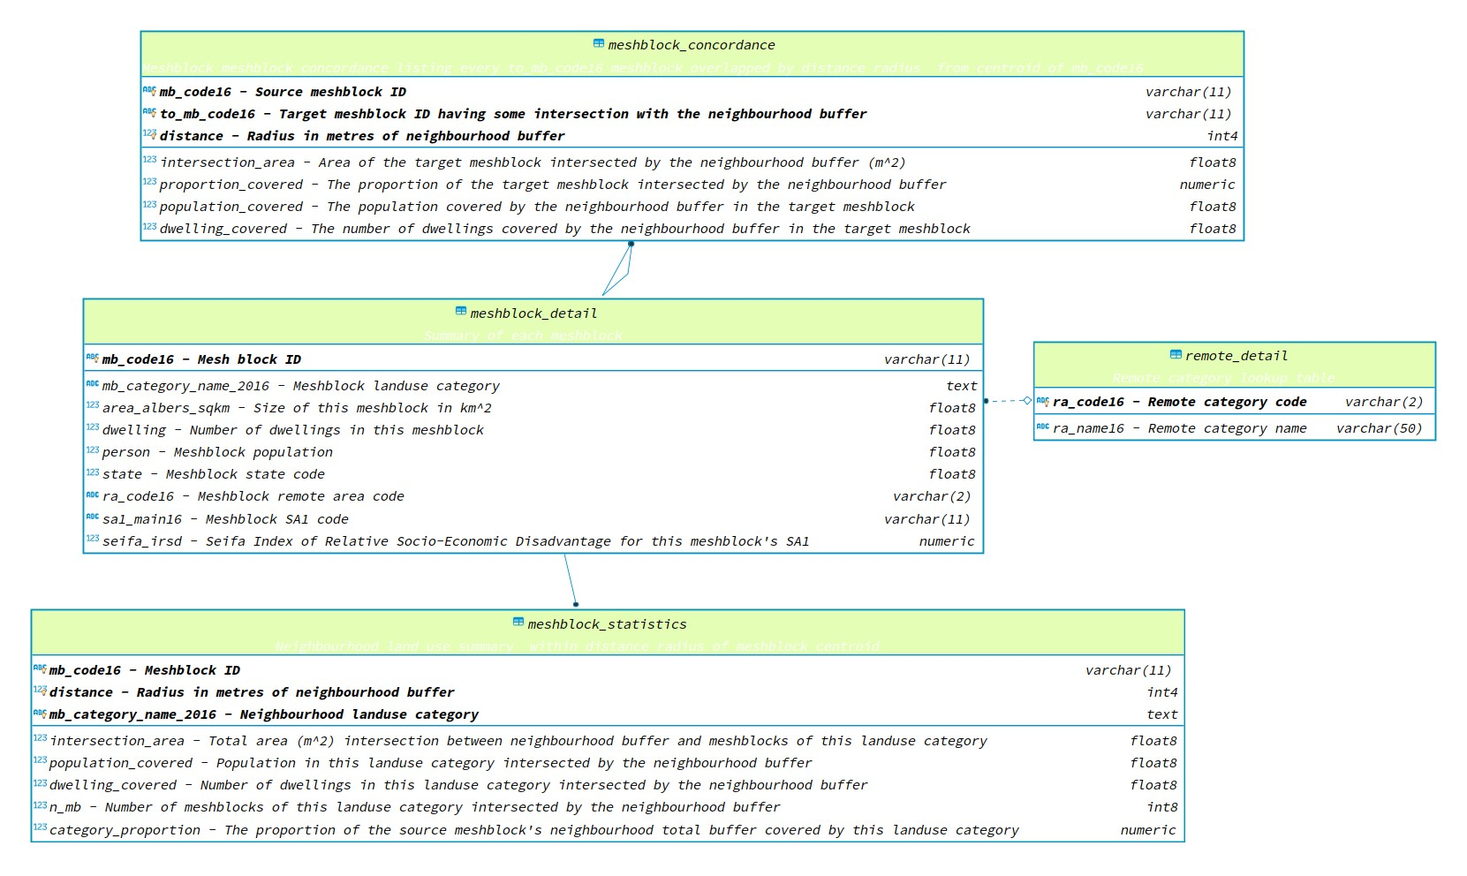

Description of fields included in each dataset file.

### Technical Validation

In relation to technical validation, the land-use of a 1% random sample of MBs across each of the four distance bands was calculated using R version 4 18 (n=3581),. Weighted centroids established via PostGIS were used. The proportion of land use for each MB across each buffer were near identical. Area calculations via PostGIS averaged 0.59% larger than calculations established by R. Calculations via both methods were significantly correlated, producing Pearson’s product-moment correlation coefficient of 1 across all distance bands. Table 3 below clarifies the total area covered for each buffer level computed via both methods, and the difference in coverage.

**Table 3: Validation findings table**

|  |  |  |  |  |  |  |
| --- | --- | --- | --- | --- | --- | --- |
| **Buffer Radius (in meters)** | **Postgis Total Area (km2)** | **R Total Area (km2)** | **Difference in Coverage (km2)** | **Percentage Difference in Coverage** | **Correlation Coefficient (R)** | **P-Value** |
| 400 | 1741.50 | 1731.22 | 10.27905 | 0.59 | 1 | <.001 |
| 1000 | 10645.57 | 10583.01 | 62.56157 | 0.59 | 1 | <.001 |
| 2000 | 41613.12 | 41369.31 | 243.81091 | 0.59 | 1 | <.001 |
| 5000 | 249719.29 | 248264.88 | 1454.40649 | 0.58 | 1 | <.001 |

Figure 3 is a map of inner city Brisbane where the percentage of commercial area within a 5-kilometre radius of every MB has been illustrated. Figure 4 is a violin plot, where the width of the violin is indicative of the relative proportion of residential of MBs across Australian capital cities and the Australian Capital Territory, which have a certain percentage (x-axis) of parkland within their 5-kilometre radius. For example, compared to all other capital cities, the Australian Capital Territory has the highest proportion of residential MBs with over 25 percent parkland coverage within their 5-kilometre radius.

**Fig 3.**



Percentage of commercial land-use within a 5-kilometre buffer of all inner-city Brisbane mesh blocks.

**Fig 4.**

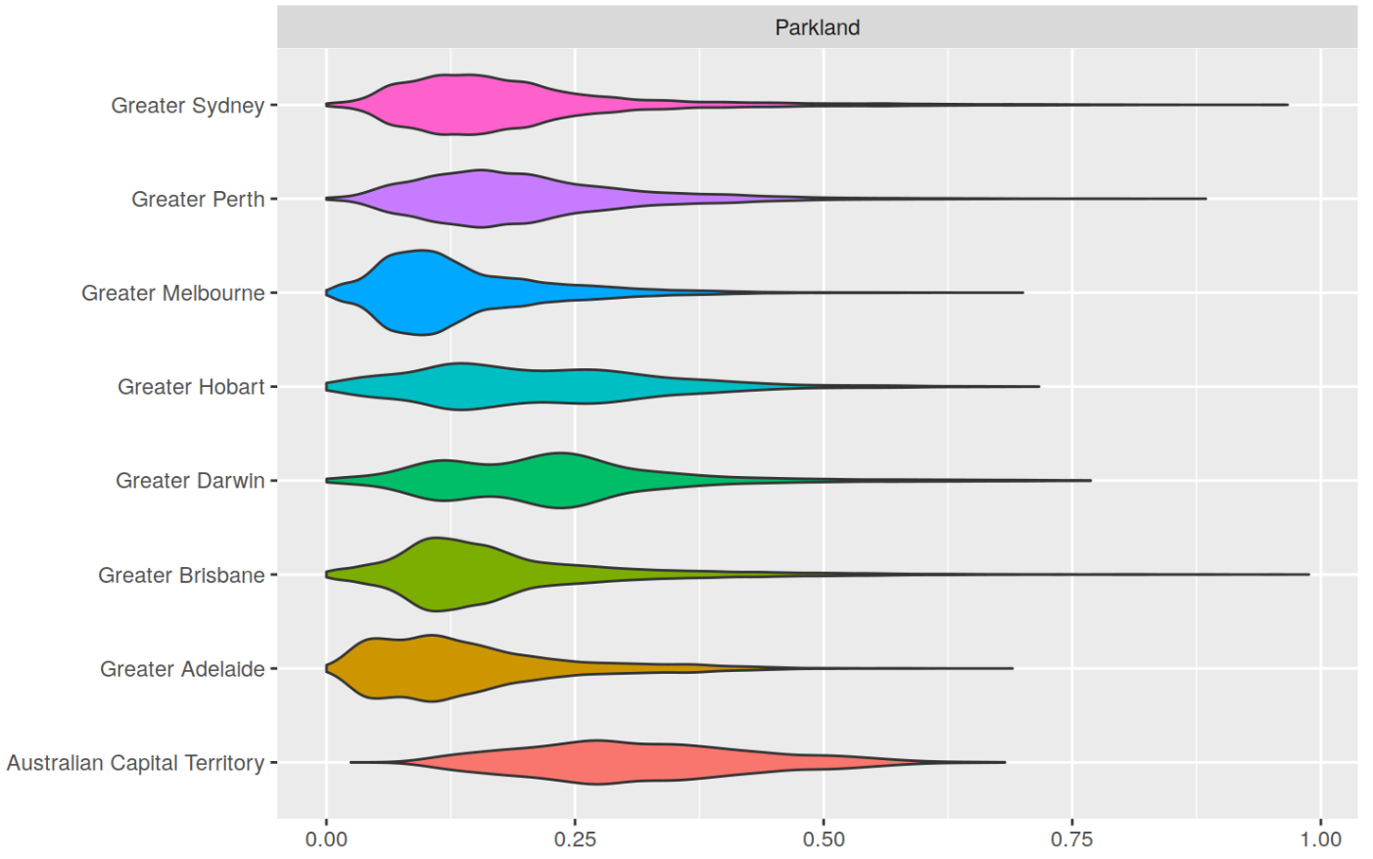

Violin plot of parklands available within a 5-kilometre buffer of residential areas within Australian capital cities and the Australian Capital Territory.

### Code Availability

The data load scripts, SQL code and R code can be found at http://github.com/dewoller/australia_neighbourhoods.

### Acknowledgements

This research was partially funded by a La Trobe University Science, Health and Engineering College Start-Up grant.

### Author contributions

AL initiated the idea, lead the development of this manuscript, and the analysis presented in this manuscript. DW conducted data analysis and data validation.

### Competing interests

The authors have no competing interests to declare.

### References

1 Park, Y., Huang, S.-K. & Newman, G. D. A Statistical Meta-analysis of the Design Components of New Urbanism on Housing Prices. *Journal of Planning Literature* **31**, 435-451, doi:10.1177/0885412216667898 (2016).

2 Baptista, R. & Mendonça, J. Proximity to knowledge sources and the location of knowledge-based start-ups. *The Annals of Regional Science* **45**, 5-29, doi:10.1007/s00168-009-0289-4 (2010).

3 Botticello, A. L., Rohrbach, T. & Cobbold, N. Disability and the built environment: an investigation of community and neighborhood land uses and participation for physically impaired adults. *Annals of epidemiology* **24**, 545-550 (2014).

4 Manaugh, K. & Kreider, T. What is mixed use? Presenting an interaction method for measuring land use mix. *Journal of Transport and Land Use* **6**, 63-72 (2013).

5 Mavoa, S. *et al.* Identifying appropriate land-use mix measures for use in a national walkability index. *Journal of Transport and Land Use* **11**, 681-700 (2018).

6 Wu, Y.-T. *et al.* Land use mix and five-year mortality in later life: Results from the Cognitive Function and Ageing Study. *Health & Place* **38**, 54-60, doi:<https://doi.org/10.1016/j.healthplace.2015.12.002> (2016).

7 Mackenbach, J. D., Randal, E., Zhao, P. & Howden-Chapman, P. The Influence of Urban Land-Use and Public Transport Facilities on Active Commuting in Wellington, New Zealand: Active Transport Forecasting Using the WILUTE Model. *Sustainability* **8**, doi:10.3390/su8030242 (2016).

8 Zhao, Y. & Chung, P.-K. Neighborhood environment walkability and health-related quality of life among older adults in Hong Kong. *Archives of Gerontology and Geriatrics* **73**, 182-186, doi:<https://doi.org/10.1016/j.archger.2017.08.003> (2017).

9 Howell, N. A., Tu, J. V., Moineddin, R., Chu, A. N. & Booth, G. L. Association Between Neighborhood Walkability and Predicted 10-Year Cardiovascular Disease Risk: The CANHEART (Cardiovascular Health in Ambulatory Care Research Team) Cohort. *JOURNAL OF THE AMERICAN HEART ASSOCIATION* **8**, e013146, doi:10.1161/JAHA.119.013146 (2019).

10 Australian Bureau of Statistics. *1270.0.55.001 - Australian Statistical Geography Standard (ASGS): Volume 1 - Main Structure and Greater Capital City Statistical Areas*, <<https://www.abs.gov.au/ausstats/abs@.nsf/Lookup/by%20Subject/1270.0.55.001~July%202016~Main%20Features~Overview~1>> (2016).

11 State of the Environment Australia. *Livability: Urban amenity* 2016).

12 Duncan, D. T., Aldstadt, J., Whalen, J., Melly, S. J. & Gortmaker, S. L. Validation of Walk Score® for Estimating Neighborhood Walkability: An Analysis of Four US Metropolitan Areas. *International journal of environmental research and public health* **8**, 4160-4179, doi:10.3390/ijerph8114160 (2011).

13 Permier of Victoria. (Victoria State Government, 2020).

14 Australian Bureau of Statistics. *1270.0.55.005 - Australian Statistical Geography Standard (ASGS): Volume 5 - Remoteness Structure* <<https://www.abs.gov.au/ausstats/abs@.nsf/Lookup/by%20Subject/1270.0.55.004~July%202016~Main%20Features~Summary%20Table~7>> (2016).

15 Australian Bureau of Statistics. (2016).

16 Australian Bureau of Statistics. *2074.0 - Census of Population and Housing: Mesh Block Counts, Australia, 2016*, <<https://www.abs.gov.au/AUSSTATS/abs@.nsf/Lookup/2074.0Main+Features12016?OpenDocument>> (2017).

17 The PostgreSQL Global Development Group. (2020).

18 R Core Team. *R: A language and environment for statistical computing*, <<https://www.R-project.org/>.> (2020).

19 Wickham, H. *et al.* Welcome to the Tidyverse. *Journal of open source software* **4**, 1686, doi:10.21105/joss.01686 (2019).

20 Pebesma, E. Simple Features for R: Standardized Support for Spatial Vector Data. *The R Journal* **10**, 439-446, doi:<https://doi.org/10.32614/RJ-2018-009> (2018).

21 Allaire, W. J. J. *et al.* *rmarkdown: Dynamic Documents for R*, <<https://rmarkdown.rstudio.com>> (2020).

22 Wollersheim, D. & Lakhani, A. *Australian Geographic Neighbourhood Summary*, <<https://doi.org/10.26181/5f583219bd440>> (2020).